After creating the springboot project, we need create a jsp file for viewing.
JSP file in springboot needs to be stored under a folder named ‘webapp’ under the ‘main’ folder.
<%@page language= "java" %>
This is used to denote this is a jsp page and there might be java written into it. Below is the index.jsp file:
<%@page language= "java" %>
<html>
<body>
<h2>Hello World !!! </h2>
</body>
</html>

But how will we connect the jsp page with the server? That’s why we need to have a controller.
So, create a file for controller and to denote that this is the controller, you need to add the annotation: @Controller
And this controller file will return the .jsp file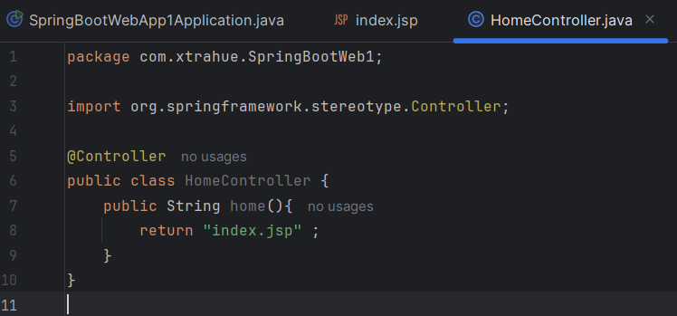

But, now if we run the main file, still it won’t work. As, we haven’t mapped the url with the controller, this mapping is required to know when to call this controller class.
You can map using the @RequestMapping. 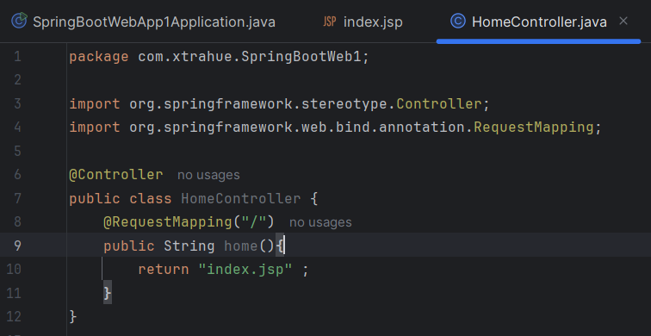
But, still if we open localhost, it will show a popup to download the index.jsp file.
We have to convert this index.jsp to servlet. We can do that by adding the tomcat-jasper dependency.

